The Tech Center at Yorktown,
Northern Westchester Hospital, and
Hudson Valley Hospital Center
New Visions
Health

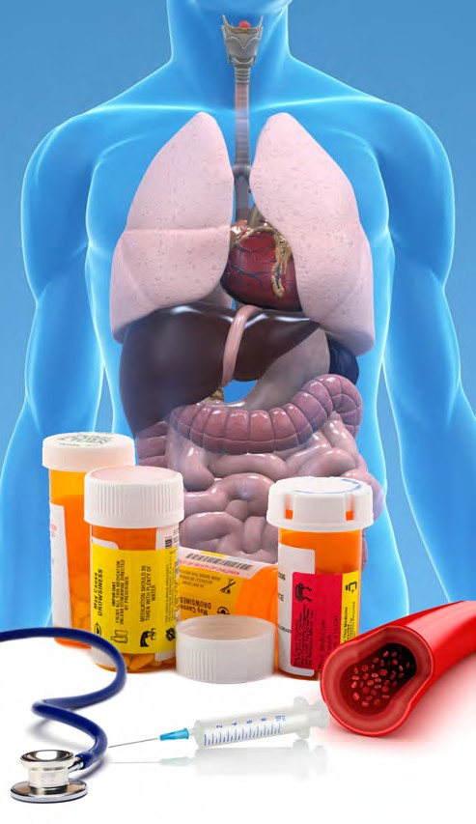
The Tech Center at Yorktown,
Northern Westchester Hospital, and
Hudson Valley Hospital Center

New Visions
Health
Honors Level Prof essional Studies Program

For more inf ormation, please call

914-248-2427
www.pnwboces.org/tech

Putnam/Northern Westchester BOCES
200 BOCES Drive
Yorktown Heights, NY 10598-4399

The Tech Center at Yorktown, Northern Westchester Hospital, and Hudson Valley Hospital Center
New Visions
Health
Honors Level Professional Studies Program

Honors Level Prof essional Studies Program

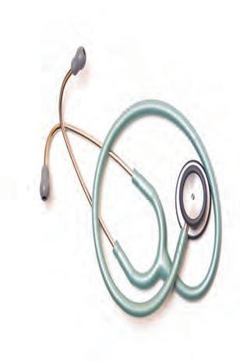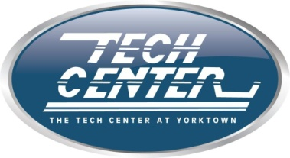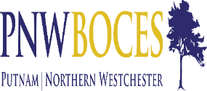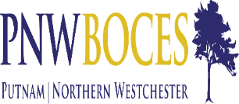
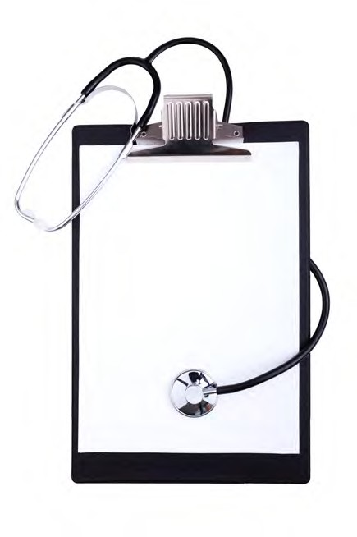
So, you want
a career in the
health field?
If you are a highly motivated, successful high school senior then you have the opportunity to earn high school credits while gaining
practical, health related career knowledge and skills. Work side-by-side with doctors, nurses, pharmacists, and other healthcare profession- als while rotating through all departments of the hospital. Gain high school credits in English 12, social studies, Phys Ed, and health occupations through projects completed during clinical assignments and internships. In addition, students have the opportunity to earn 12 college credits; 6 credits for SUNY Composition and Literature or Written English and Literacy,( English 111 and English 112), 3 credits for Mercy Political Science in America , and 3 credits for SUNY Medical Terminology.

Units of Study

• Diversified Health Occupations
• Structure and Function of the Human
Body
• SUNY WCC English 111 and 112
• SUNY WCC Medical Terminology
• Mercy College Political Science in America

Career Exploration

• Dietician
• Physician
• Health Administrator
• Nurse
• Pharmacist
• Physical Therapist
• Physician’s Assistant
• Respiratory Therapist
• Surgeon
• Clinical Lab Technician

Requirements for Admission

• High School senior with an
85 or better overall average
• Successful completion of three
years of math
• Successful completion of three
years of science
• Recommendations from a teacher
and a Guidance Counselor
• Successful interview with
New Visions Admissions Panel
• Physical Examination & flu vaccine
• CPR Certified
• English Essay

How Will My
Schedule Work?

You spend two days a week from
8:00 a.m. until 12:00 p.m. at either Northwell Northern Westchester Hospital in Mount Kisco, NY or NYP/Hudson Valley Hospital Center in Cortlandt Manor, NY. The other three days are spent in the New Visions classroom located in the Tech South building at the Tech Center at Yorktown from 8:00 a.m. to
12:00 p.m.

What are Grades Based On?
• Academic exams and/or quizzes
• Independent and group learning
projects
• Work site supervisors’ evaluations of
job performance, depth of
understanding, and professionalism

How Will This
Program Look to Colleges
New Visions programs have been in existence for over 10 years and have gained an excellent reputation among post-secondary institutions. Graduates have attended some of the top colleges and universities in the country.

